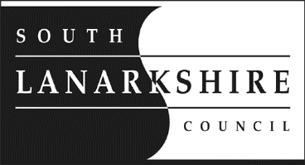
Education Resources
6 September 2021

Dear Parent/Carer

I can confirm that we have several positive cases of Covid-19 and NHS Lanarkshire’s Test and Protect team will be carrying out contact tracing.
The individuals are currently self-isolating at home.
Can I guide you to the letter on our website/twitter signed by Dr John Logan, Acting Director of Public Health, NHSL which explains clearly the new procedure for schools when we are notified of a positive case within the school.
As previously detailed whole classes will no longer be asked to self-isolate if someone in the class tests positive for COVID-19. There will be no requirement for your child to self-isolate unless you are contacted by Test and Protect – the contact tracing service.
I would wish to reassure you that we have in place all the recommended infection prevention and control measures and a thorough cleaning programme for our building.

It remains important to remember that mixing socially in the community without maintaining physical distancing measures helps the virus to spread widely. It is therefore important that people remain vigilant and follow physical distancing guidance, including during school drop off and pick up. Pupils and staff should wash their hands thoroughly and regularly using soap and water for 20 seconds.

Individuals who experience any Covid-19 symptoms such as a cough, fever or loss of taste or smell, even if they are mild, should stay off school or work and get tested. Information on how to access testing is available at: www.gov.uk/get-coronavirus-test

If you have any questions about coronavirus please visit www.nhsinform.scot in the first instance, or call the helpline on 0800 028 2816.

Mrs J McColl
Head Teacher
Park View primary School

